**MSU two tier Architecture Use case**

1. **Introduction**

MSU two tier network architecture will have following naming convention MSU Server, MSU Master and MSU client/slave. Where MSU server is a application running on windows PC, MSU Master the device which will have both capabilities ( Server and Client) and MSU Client/Slave is the device which is expecting file from MSU Server through MSU Master.

MSU Master will not have full fledge MSU server feature as like PC application instead it will have minimal feature to achieve file deployment to all its locally connected Slaves/Clients.

MSU Server can’t communicate to MSU Client /Slave directly, MSU master will communicate on behalf of it. MSU Server need to instruct MSU Master and MSU master will ask MSU Client/Slave to perform the action as per Server wish.

Upgrade process would be completed in 2 step/cycle

* Server will upgrade master
* Master will upgrade client/Slave

This case sever first transfer the file to Master using normal MSU upgrade process, than Server will instruct Master to deploy received file to all of its locally connected Slaves/Clients.

MSU Server can download file to more than one master simultaneously and all Master are responsible to download same file to device connected to their respective network.

After the issuing upgrade command by Server Master will start downloading file using normal MSU upgrade process to all the Clients/Slave connected locally to it.

Master will only responsible of downloading files to Slaves/Client connected to its locally on network, there would not be any communication between master of one subnet and Slave/Client of other subnet.

There could be possibilities of two kind of network present in field.

* **Singular Network** - network of same type of MSU Supported devices i.e (H1)



**Fig-1 : Network Architecture for Singular Network**

* **Hybrid Network** - Network of combination of many type of MSU Supported devices (H1, H2,H3)



**Fig-1 : Network Architecture for Hybrid Network**

1. Network Scanning: Scanning of network completed in 3 cycle.
   * Master Scanning
   * Instruct Master to scan all Slaves/Clients connected to its subnet
   * Get the scan list from Master one by one

MSU server first scan all the Master connected on entire network. Master Scan command can be Multicast or unicast message type.

Once Server get list of all masters it sends request to all Masters to scan it locally connected Slaves/Clients.

Master sends scan command to it locally connected Slaves, message type can be Multicast/Unicast depend on the traffic and bandwidth of the network. Master will collect all the information and generate a report, this report can have multiple section each section will have similar kind of the device list. So if there is many type of device connected on a subnet than this report will have many section, number of section is propionate to number device types.

MSU server will read this report from Master one by one, if report size does not fit in one transaction than sever can initiate multiple transaction to read complete report.

Master can generate this report dynamically or statically, for dynamic generation above option will be use and static generation can be done @ the time of network setup. All the information of Slaves, required by Master put into a configuration file. When Server request for read Scan report from Master it simply read from configuration file and send to Server.

There are few use case have to handle in case static report:

* Is Device still Alive-> if Slave is dead or removed from subnet than Master MUST delete from the report to avoid the confusion at Server application.
* Is the files version same -> Master MUST create report where Server should come to know the version of file even the device type is same.

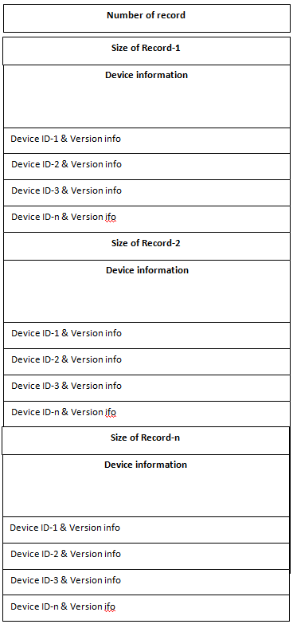

**Fig: Slaves Report**

1. Singular network :-> All the devices connected on the network is same type and expected same binary type/version to be upgraded. In such network ,upgrade process can be completed in two step :->
   * Server to Master
   * Master to Slave/Clients

**Server**

**Master**

**S1**

**S2**

**Sn**

Where S1, S2 and Sn is same H/W and expected same binary from Server

1. Hybrid Network (Network with may device type) : Device connected in the subnet could many type and expected different binary for different devices. This case upgrade process can be achieve by two way
   * Server Download one file one time to Master and instruct Mater to download same to all relevant Clients/Slaves connected its locally. Take another and repeat till download all relevant file to relevant H/W.
   * Server download all different files for different H/W device to Master one by one first. than Server will instruct Master to download those files to their respective H/W types one by one in sequence.